

NORTH SOUTH UNIVERSITY

Department of Electrical & Computer Engineering

**Project Report**

**Group No: 06**

**Summer 2021**

**Project Topic:** Online Service Marketplace

**Course:** CSE 299

**Section:** 06

**Faculty:** Shaikh Shawon Arefin Shimon (SAS3)

**Project Partners:**

1. Name: Abdul Hannan Anik

ID: 1812091

Email: [hannan.anik@northsouth.edu](mailto:hannan.anik@northsouth.edu)

1. Name: Shaon Kumar Das

ID: 1812613

Email: [shaon.das@northsouth.edu](mailto:shaon.das@northsouth.edu)

1. Name: Pinaki Ranjan Das

ID: 1813087

Email: [pinaki.ranjan@northsouth.edu](mailto:pinaki.ranjan@northsouth.edu)

**Git Repository**: <https://github.com/NSU-SU21-CSE299-6/Group06>

**Date of Prepared:** 10th September 2021

# Introduction

The value of our time is constantly increasing day by day. This is why people are moving towards online services. For the household service, to get an expert household service provider is very difficult and time consuming. Our web application will help people to solve this problem. With our web application people can hire expert service providers and to get things done without any hassle. We give people the opportunity to select their required service and they can hire one of our verified professional service providers.

# Features

* Users can create an account and sign in using email.
* Users can choose the service what they need.
* Users can choose date and time for service.
* Users can request the service.
* Users can pay via online mobile banking system.
* Users can review about the service.

# User Interface

***Home Page:***

When users visit our website, the home page will be this. From this homepage user can go login, register page.

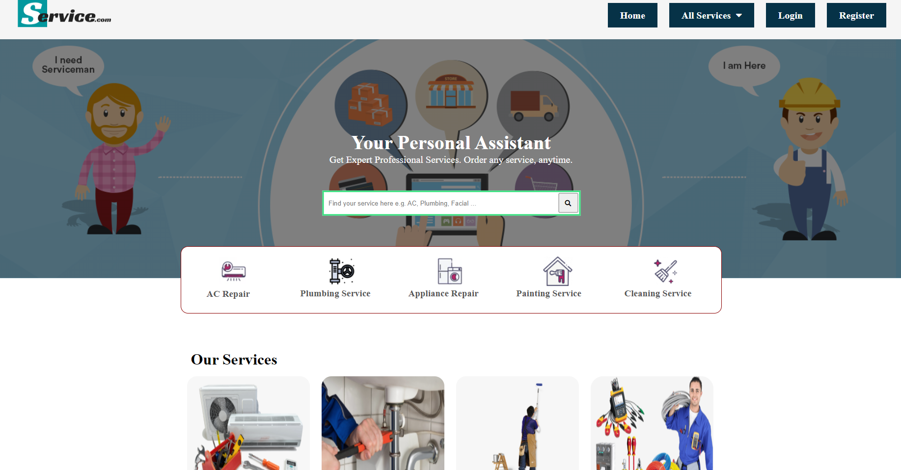

*Fig 01: Home Page*

***Login Page:***

This is Login page. User can login with email and password.

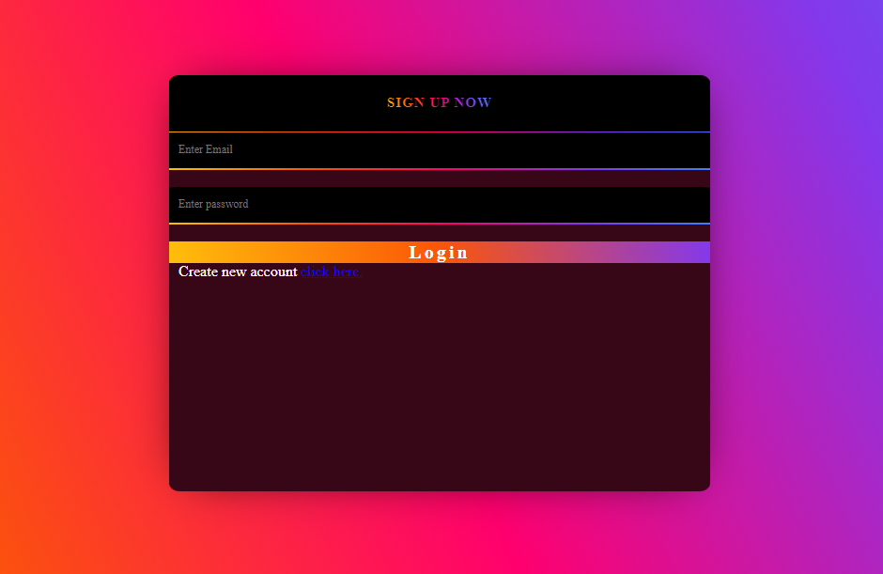

*Fig 02: Login Page*

***Registration Page:***

If users don't have any account they can register. They are required to provide their full name, email, phone number and strong password.

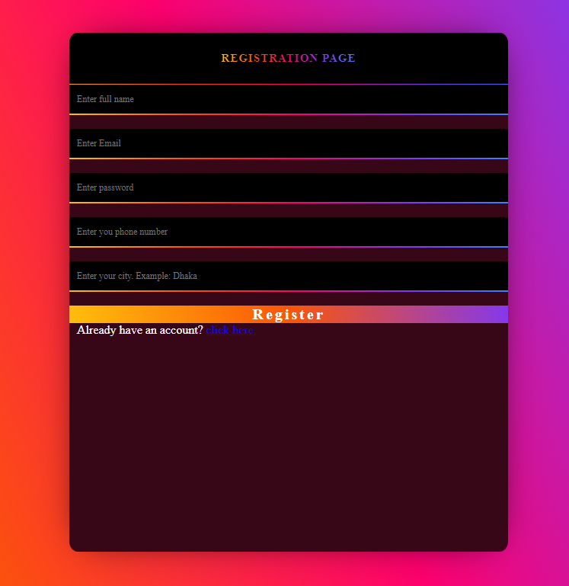

*Fig 03: Registration Page*

***Service Details Page:***

This details page has included why customer choose us and what conditions are included or excluded in our service. We also added our service description in details page.

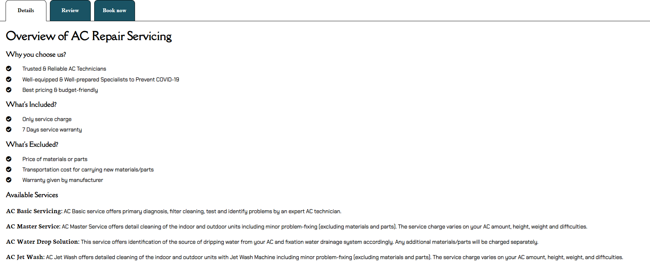

*Fig 04: Service Details*

***Review Page:***

This is review page where all the reviews are fetched directly from our database. These reviews are given by our service receiver who described how the service was and how can we improve in future.

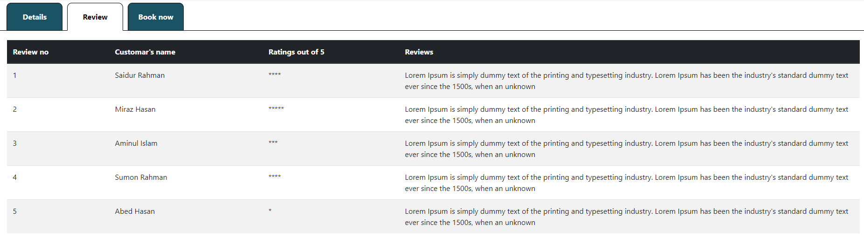

*Fig 05: Review Page*

***Book now Page:***

In this page customer order their essential service. Here service name and price are visible. Quantity select feature available where customer can select minimum 1 item and maximum 3 items. If customer add a service mistakenly, they can delete it if they want.

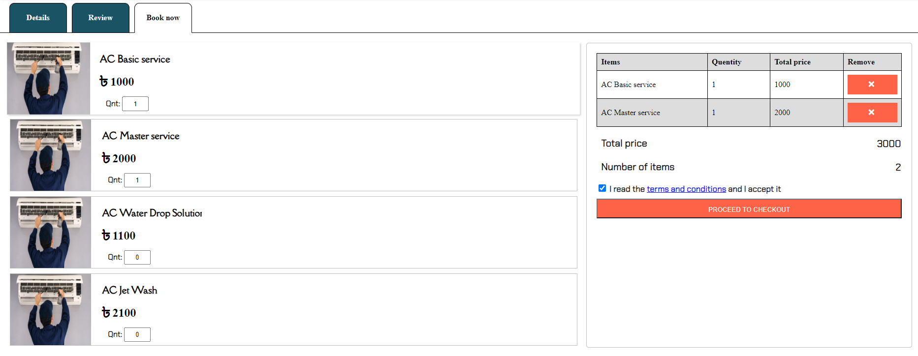

*Fig 06: Book now Page*

***Checkout Page:***

In payment page I add two options – “Continue with login” and “Continue without login”. If a customer already has an account in our website but they forget to login, they can directly login in payment page using “Continue with login” option. But if customer haven’t any account before they can continue using “Continue without login” option. But in this case, customer need to insert some information which is used to create an account automatically in our website. In payment section, customer can pay though app or USSD code. After paid, they will get a transaction ID which need to insert in payment section page and need to click verify button. After verified payment, customer can proceed next page.

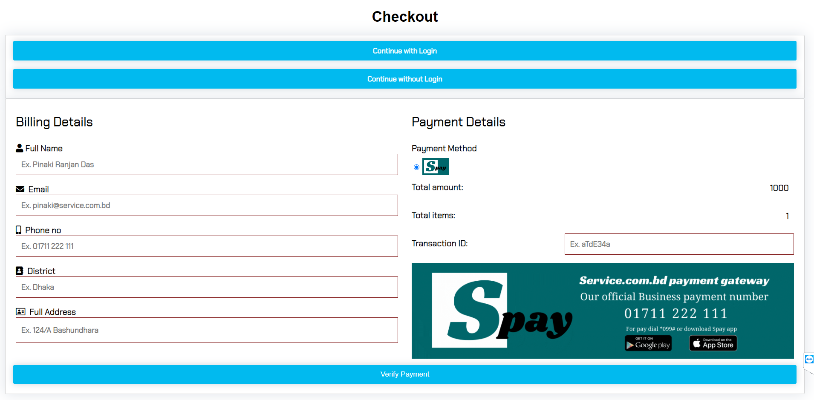

*Fig 07: Book now Page*

***Invoice Page:***

This invoice page is the final document which indicates customer registered our service. Clicked in download button, customer can download it in local machine in pdf format.

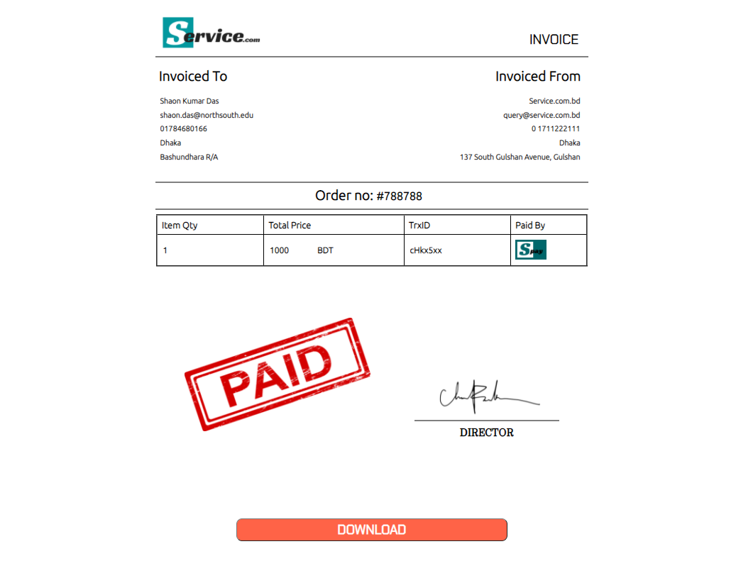

*Fig 08: Invoice Page*

# Technology

**Proposed Technology Stack:**

* ***Frontend:***

For the front-end development we will use HTML and CSS. We will use HTML to define a structure of a web page and use CSS to style the web pages by using different styling features. We will try to use React and Material-UI for better frontend design.

* ***Backend:***

For the back-end development we will use PHP and JavaScript. We will also use REST API. To develop the better project, we will try Django if needed.

* ***Database:***

For the database aspect of this project, we will use Google Firebase. Firebase give us real-time database, login authentication and cloud storage facilities.

**Implemented Technology Stack:**

* ***Frontend:***

For the front-end development we used HTML and CSS. We used HTML to define a structure of a web page and use CSS to style the web pages by using different styling features.

* ***Backend:***

For the back-end development we used JavaScript. JavaScript is a text-based programming language and it is user friendly. JavaScript gives web pages interactive elements that engage a user.

* ***Database:***

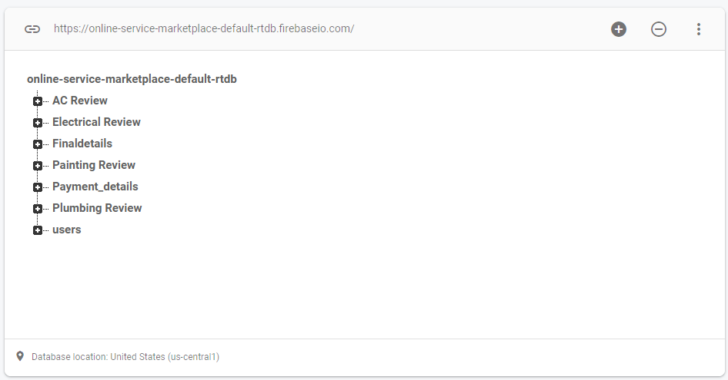For the database aspect of this project, we used Google Firebase. Firebase give us real-time database, login authentication and cloud storage facilities.

*Fig 08:* *Database*

# Monetization

We will charge 10% from service provider for every service. If the user pays via online, we will cut our percentage automatically. But if user pays through cash, service provider pays our charge via online.

**Social Impacts:**

This web application will aim to make finding suitable and better household service for home and office easier. People will get all type of household service in their hand. As all the service provider will be experienced and verified, so no worries about the quality of work.

**Future works and Plan:**

In future, we will extend our project and we will add some more services. Our main goal is that people will get all kinds of office and household services from this one web application. We would like to add the remaining services like: Beauty & Salon, Car Rental, Driver Service, Car Care Services, Security Guard and Ambulance Service.

**Conclusion:**

We wanted to develop a web application that would provide the user with a great online household service experience. People will be able to hire expert service providers through our website. The web application we created in this project can be improved. This is especially because we had to create it within a limited time. With more time, the web application can be improved to include security and different types of features and services. Learning processes and developing platforms was fun and time consuming. But the whole process, the development of the project was quite an experience for us.